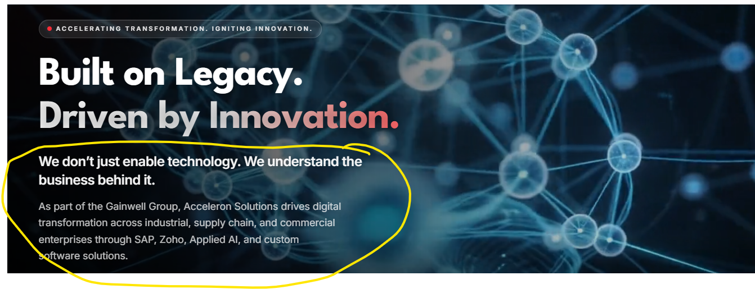
Please reduce the content:
Remove: “ We don’t just enable technology….”
Change the body text to:
Acceleron Solutions combines SAP and Zoho consulting, predictive AI and scalable custom software to solve complex operational challenges and deliver measurable business value.

Page: https://acceleron-website.vercel.app/services/sap/sap-ams
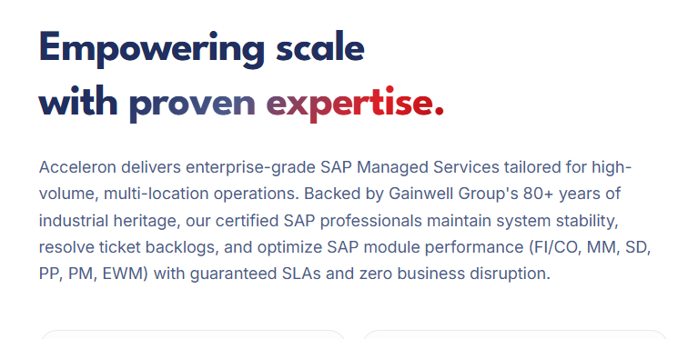

Change the body copy to:
Acceleron delivers enterprise-grade SAP Managed Services tailored for high-volume, multi-location operations. Our certified SAP professionals ensure system stability, clear ticket backlogs, and optimize SAP module performance (FI/CO, MM, SD, PP, PM, EWM), backed by defined SLAs and a commitment to uninterrupted business operations.

Page: Acceleron Solutions — Engineering Digital Excellence
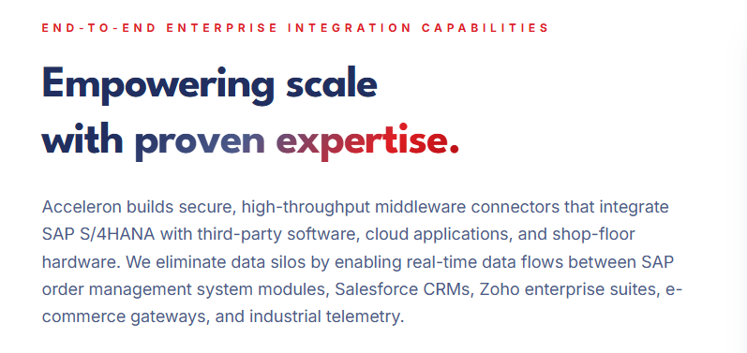
Change body text to:
Secure, high-throughput middleware connectors integrate SAP S/4HANA with third-party software, cloud applications and shop-floor hardware. Enabling real-time data exchange across SAP, Salesforce, Zoho, e-commerce platforms and industrial systems, these integrations eliminate data silos and streamline operations.
Page: https://acceleron-website.vercel.app/careers
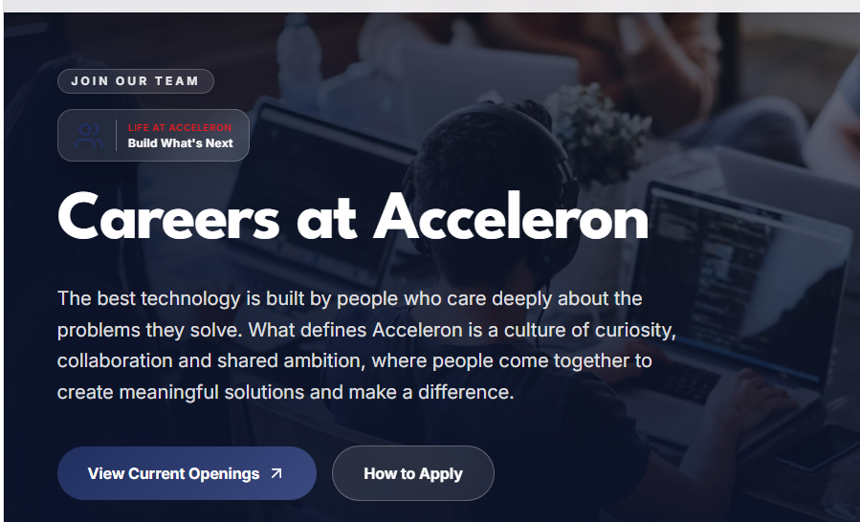
Please change body text to:
Driven by people who care deeply about solving problems, our culture thrives on curiosity and collaboration. Fostering shared ambition, we bring people together to create meaningful solutions that make a difference.
Page: https://acceleron-website.vercel.app/about
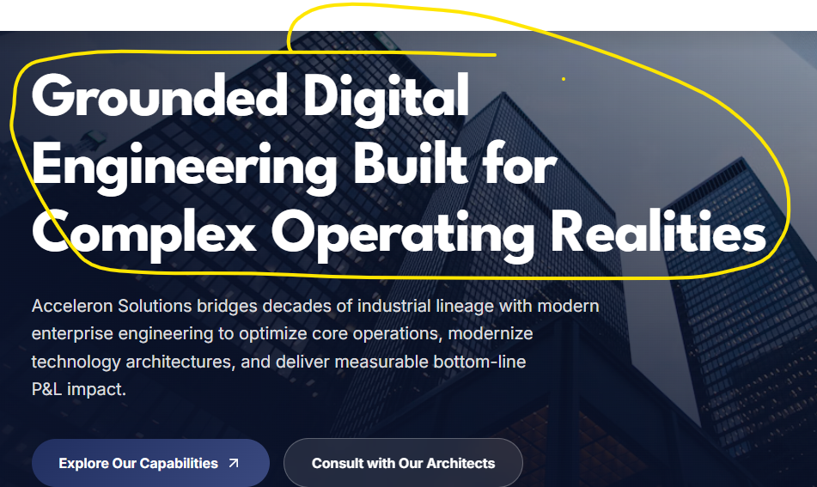
Change header to:
Digital Engineering for Complex Operations
Change body text to:
Combining decades of industrial heritage with modern enterprise engineering to optimize operations, modernize technology and deliver measurable business impact.
Page: https://acceleron-website.vercel.app/services/it-custom-solutions
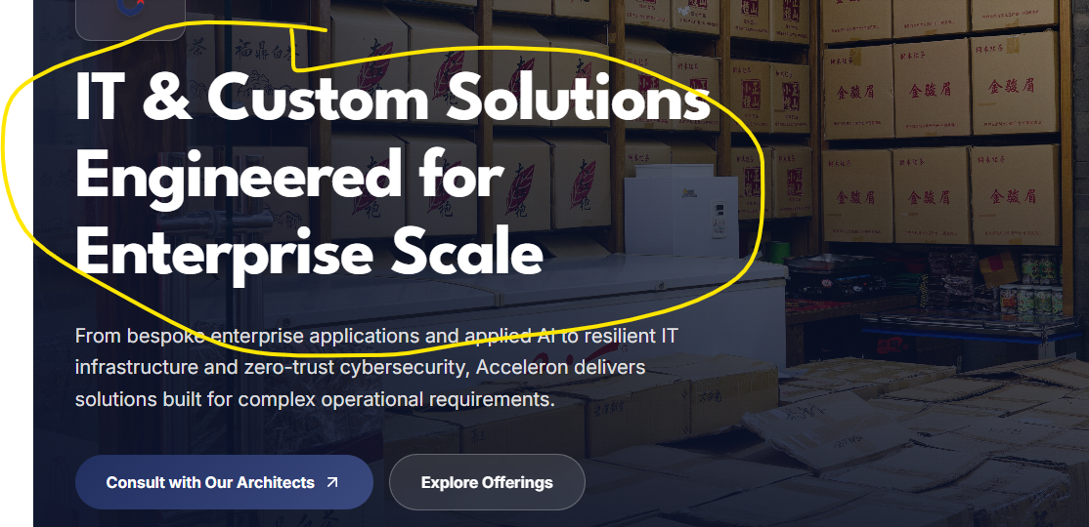

Change header to:
Custom Technology for Enterprise Needs
Page: https://acceleron-website.vercel.app/products/industrial-solutions
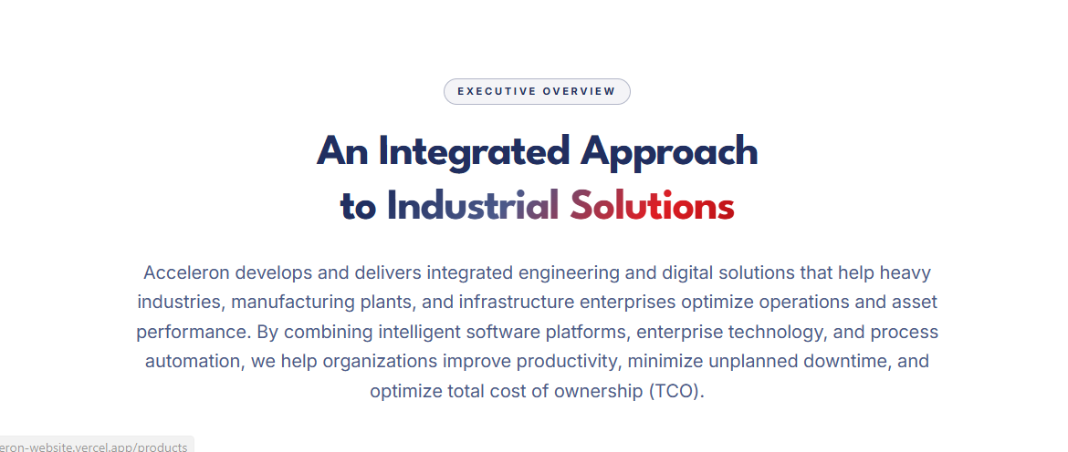
Please reduce the body copy to:
Integrated engineering and digital solutions for heavy industries, manufacturing and infrastructure enterprises, designed to optimize operations and asset performance.
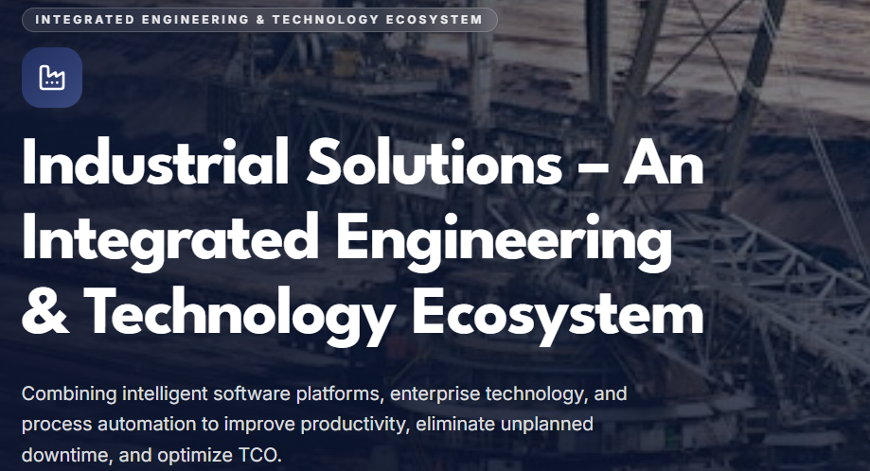
Change the header to just ‘Industrial Solutions’ (Do this for all 4 product pages)

Page: https://acceleron-website.vercel.app/services/zoho
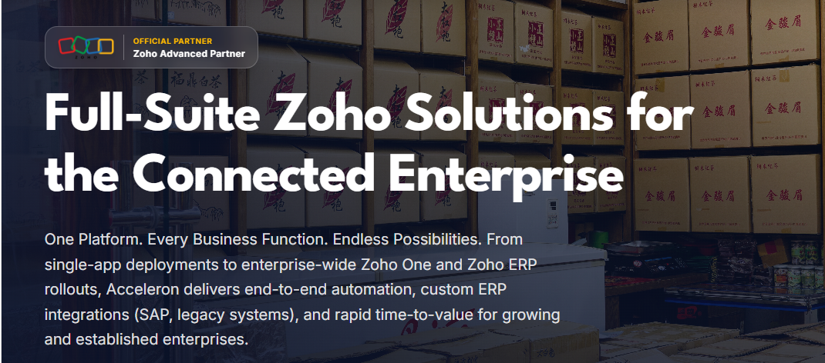
Please change the header to:
Zoho Solutions for Connected Businesses
Body content of the banner to be changed to:
From individual Zoho applications to enterprise-wide Zoho One and ERP deployments, we deliver seamless automation, custom integrations with SAP and legacy systems, and faster business value.
Page: https://acceleron-website.vercel.app/services/zoho/zoho-crm
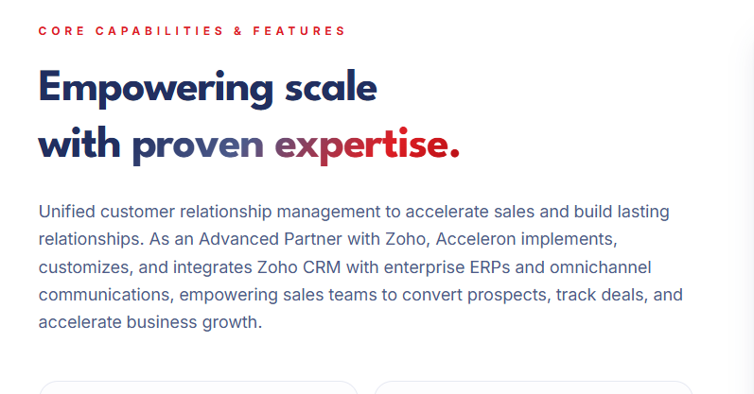
Change body content to:
Unified customer relationship management to drive sales and lasting relationships. As a Zoho Advanced Partner, Acceleron customizes and integrates Zoho CRM with enterprise ERPs and omnichannel communications, helping sales teams convert prospects, manage deals and accelerate growth.

Page: https://acceleron-website.vercel.app/about
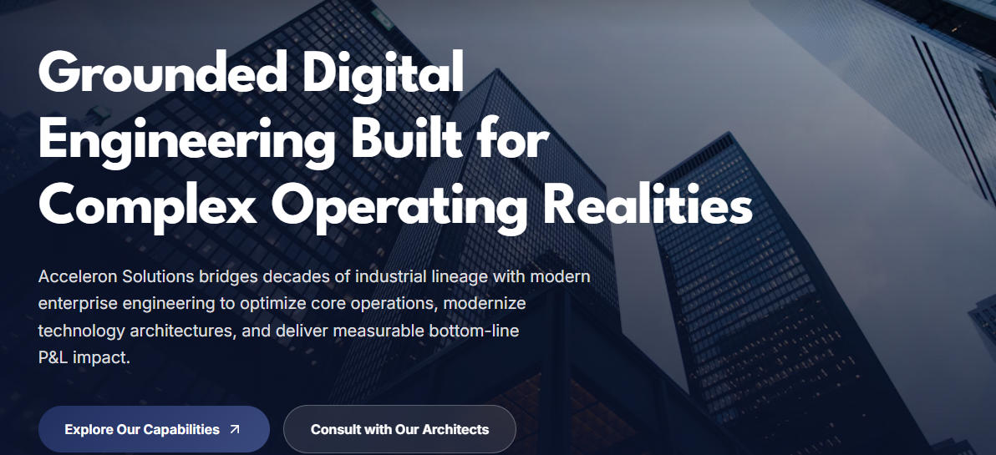
Please change header to:
Engineering Digital Solutions for Industry

Please reduce body copy to:
Great work starts with great people. We nurture curious, collaborative and accountable teams, empowering them to learn, grow and take ownership. This people-first culture shapes how we work together and deliver for our clients.
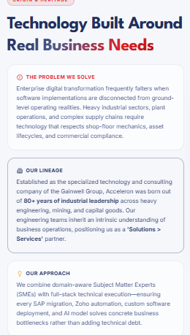

Please change content to:
Technology Built Around Real Business Needs
THE PROBLEM WE SOLVE
Digital transformation often falls short when technology is disconnected from operational realities. Heavy industries and complex supply chains need solutions that account for shop-floor processes, asset lifecycles and business compliance.
OUR LINEAGE
Born from 80+ years of industrial leadership in engineering, mining and capital goods, Acceleron combines deep operational knowledge with technology and consulting expertise to deliver integrated solutions and services.
OUR APPROACH
We bring together domain experts and technical specialists to deliver SAP, Zoho, custom software and AI solutions that address real business challenges and improve operational efficiency.

